Report Analysis
Team ID | MCA
Project Name | Smartphone Usage, Digital Addiction & Well-Being Analytics
Maximum Marks | 5 Marks

Report 1: Digital Addiction & Screen Time Behaviour Analysis
This analytical report examines the daily digital habits of smartphone users to evaluate how screen time patterns drive behavioural dependency. Preparing structured documentation in Power BI helps translate complex behavioural telemetry into direct insights for academic reviewers, project mentors, and wellness researchers.
The report design integrates raw mobile interaction logs into clean visual formats. Slicers and segmented bar charts allow evaluators to filter data across distinct cohorts, uncover habit loops, and assess how daily digital interruptions shape phone dependency across diverse demographic profiles.
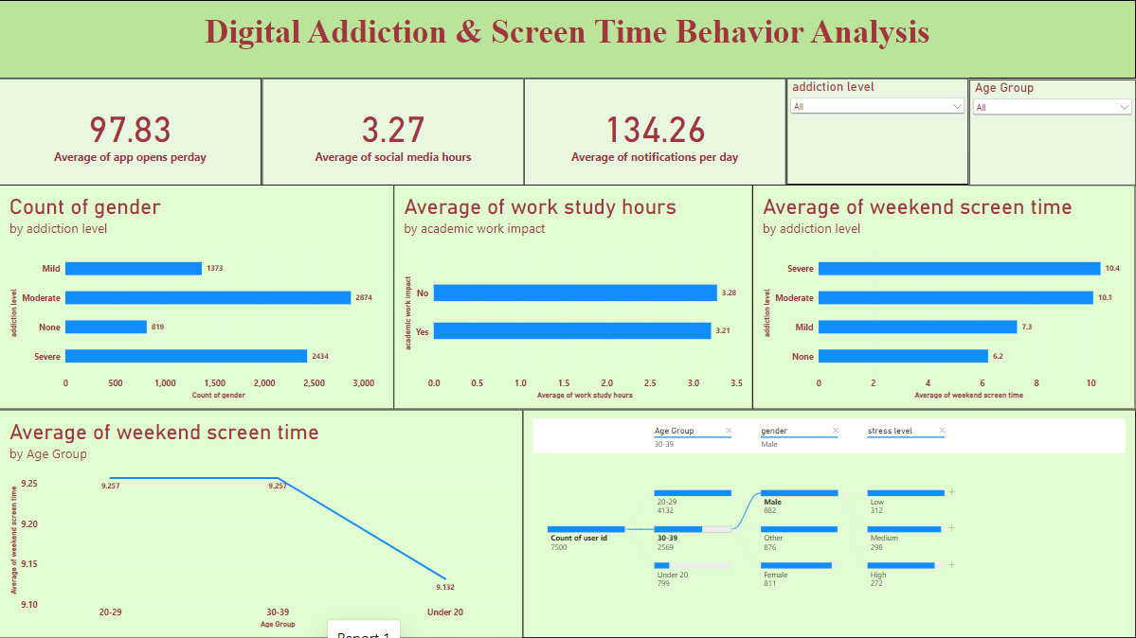

Observations Drawn from Report 1
Detailed analysis of the Report 1 visuals shows important insights about daily user behaviour and phone engagement:
1. Application Usage and Alerts:
- Daily App Opens: Users open various applications around 97.83 times per day, which clearly shows continuous checking habits throughout the day.
- Social Media Screen Time: On average, users spend 3.27 hours daily just browsing social networking platforms.
- Daily Notifications: Users receive an average of 134.26 alerts each day, which acts as the major reason for repeated phone pickups.

2. User Addiction Categories:
- High Addiction Numbers: The horizontal bar chart shows that 2,874 users have Moderate addiction and 2,434 users have Severe addiction, covering most of the total candidates.
- Lower Dependency Groups: Only 1,373 users come under Mild addiction, while just 819 users have None (zero addiction symptoms).

3. Weekend Screen Time Trends:
- Weekend Usage Rise: Over the weekend, phone usage increases heavily with addiction levels, hitting 10.4 hours for Severe and 10.1 hours for Moderate users, whereas non-addicted users spend only 6.2 hours.
- Age Group Comparisons: Both 20–29 and 30–39 age brackets spend 9.257 hours on weekends, while youngsters Under 20 spend slightly less at 9.132 hours.

4. Work and Academic Performance:
- Study and Work Hours: Students and working professionals average nearly the same study/work time of 3.28 hours (for those reporting No impact) and 3.21 hours (for those reporting Yes, impacted).

5. Detailed User Split (Decomposition Tree):
- Demographic Breakdown: Looking at the 30–39 age category (2,569 users), Male participants (882 users) show a balanced spread across stress ratings, with 312 having Low, 298 having Medium, and 272 having High stress levels.

Report 2: Smartphone Addiction & Digital Well-Being Insights
This study focuses on identifying the primary behavioural factors behind digital dependency and their measurable effects on physical well-being and lifestyle balance. Using Power BI data modelling, complex interactions—including machine learning key influencers, demographic splits, and sleep trends—are organized into a structured visual format.
The visual layout enables clear comparisons between regular and excessive screen time users, illustrating how specific habits such as extended social media browsing directly influence sleep duration, self-reported stress, and digital addiction risks.
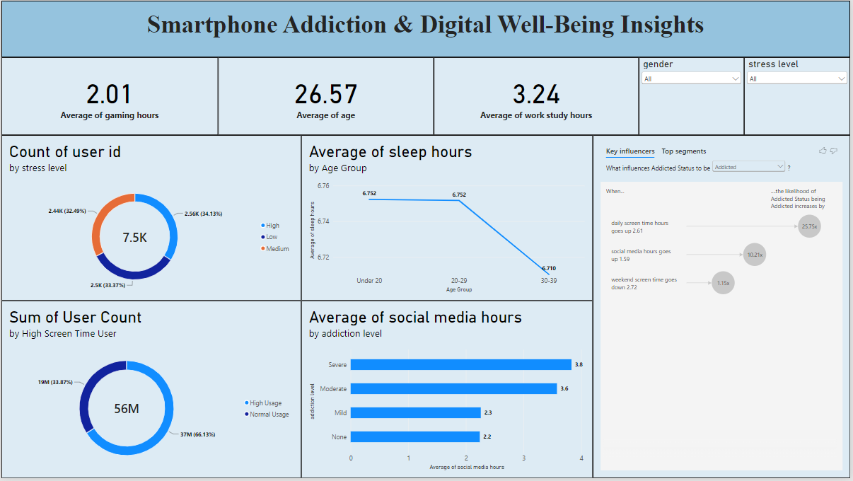
Observations Drawn from Report 2
The charts and smart visuals on this canvas highlight several critical well-being patterns:
1. General Metrics & Cohort Demographics:
- Average Age: The average age of surveyed individuals is 26.57 years, confirming that the findings represent college students and young working people.
- Gaming Hours: Candidates spend around 2.01 hours daily playing mobile games.
- Productive Hours: Average time dedicated to work and studies stands at 3.24 hours per day.

2. Stress and Screen Time Classifications:
- Stress Distribution: Users are distributed almost equally into three stress levels: High Stress at 34.13% (2.56K users), Medium Stress at 33.37% (2.5K users), and Low Stress at 32.49% (2.44K users).
- Screen Time Groups: Around 66.13% of users fall into the High Usage group, while only 33.87% maintain Normal Usage.

3. Social Media Dependency:
- Direct Increase with Addiction: Users with Severe addiction spend 3.8 hours and those with Moderate addiction spend 3.6 hours on social networks, compared to just 2.2 hours spent by users with no addiction.

4. Sleep Patterns by Age:
- Sleep Drop in Working Adults: Average sleep remains steady at 6.752 hours for candidates Under 20 and those aged 20–29, but falls to 6.710 hours for individuals aged 30–39.

5. Key Influencer Analysis:
- Main Addiction Factor: When daily screen time increases by 2.61 hours, the chances of becoming Addicted jump by 25.75 times.
- Social Media Influence: An increase of 1.59 hours in social media usage multiplies the risk of addiction by 10.21 times.
- Weekend Usage: Weekend screen duration further adds a 1.15 times increase in addiction likelihood.

